Third Project-Smart Solar Panel.

|  |
| --- |
| Fabian Pinzon Motta, Nicolás Nieto Ordosgoitia |
| Electronic Engineering Department |
| Pontificia Universidad Javeriana  [fabian.pinzon@javeriana.edu.co](mailto:fabian.pinzon@javeriana.edu.co), [nietonicolas@javeriana.edu.co](mailto:nietonicolas@javeriana.edu.co) |
|  |

**INTRODUCTION**

This Project has been implemented by C, programming language. Additionally, we use as development platform the microcontroller X-MEGA 128B1, where we execute a set of instructions with the final purpose of control the functioning of a solar panel self-sufficient, executing a code which with external information is able to make a decision. All this is possible thanks to sensor measurement and execution of actuators, who can influence in the state of the system. Besides, is a renewable energy and brings to environmental care.

**SYSTEM SIZING**

Will be designed a C code that can control a solar panel taking into account the environmental conditions.This will be done through the medition of the light intensity, factor that affect the functioning of the panel, to obtain this data will be used a electronic component called “photoresistor”. Will be implemented actuators like a servo who can make changes in the position and reach the desired conditions. The servo works through a Pulse Width Modulation (PWM) signal which let to assign a position to the servo and keep it until the signal changes. The system charges a 9 volts battery which is in charged of keep the energy for reserve. Finally, the system has a USB port for power supply.

Additional to this will be to took advantage the functionality of the TTL to send the panel’s voltage and battery’s voltage.

**SOLUTIONS DESCRIPTION AND JUSTIFICATION.**

In the picture number 5 will be shown the Finite State Machine corresponding to the system which describes the behavior of the solar panel. There are four main states which has different transitions to change among them and each one is in charge to mode specific condition request. The first state called ESPERAR, when the machine is in this state it will read the assigned value for each channel by ADC. Then will be evaluated the value of each one and will be compared between them, after this the machine will decide if should get up or get down depending of the analog read of the photoresistor. The movement will be done by the servo through the change of position in favor of the light location, this procedure will be handled through the PWM signal.

The photoresistor function as a voltage divider which allows send to the microcontroller a ADC signal that will be interpreted as an input and will let you know the value of the light intensity.

Will be used a regulator lm7809 which will be in charge of keep the output voltage constant with value of 9V, this will let charge the battery constantly.

An important component is the diode 1n4004 which doesn’t allow the current flow in the opposite direction, without it, the panel would be able to discharge the battery when the panel has less current than the battery.

**TEST AND RESULTS ANALITICS**

For test protocol, we implemented some test where we check the well working of the project.

1.First test: The first test consists in block the light of one of the photoresistor, the code must be able to move the panel to the opposite side.

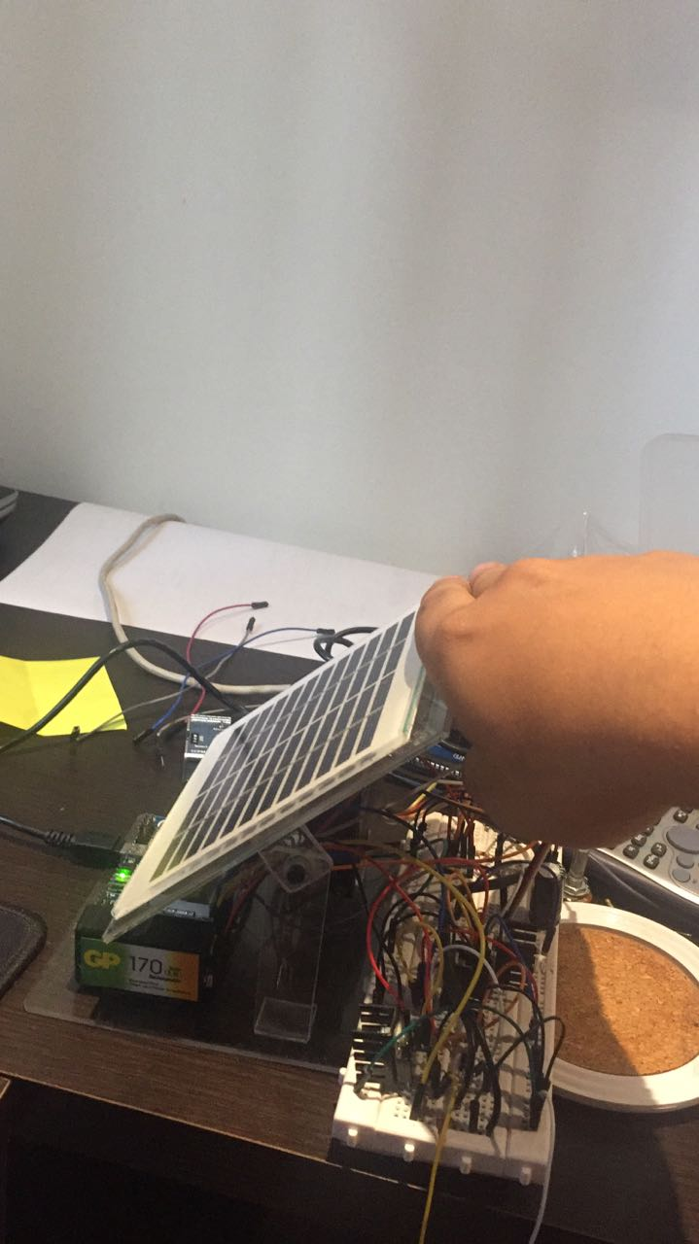

Picture 1. Panel’s test.

2.Second Test: In this case we use the same test used in the first, checking the second photoresistor’s work.

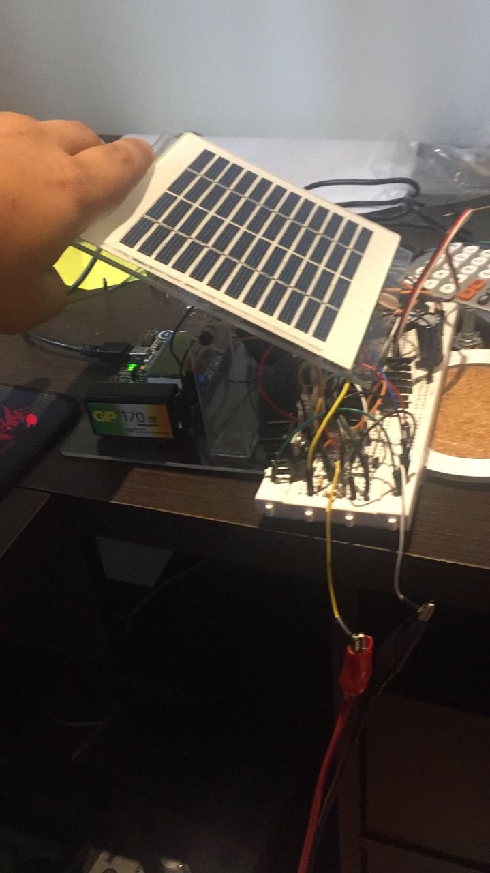

Picture 2. Second panel’s test.

3.Third test: Now we checked with the room’s light and it points directly to the bulb. Such as we expected.

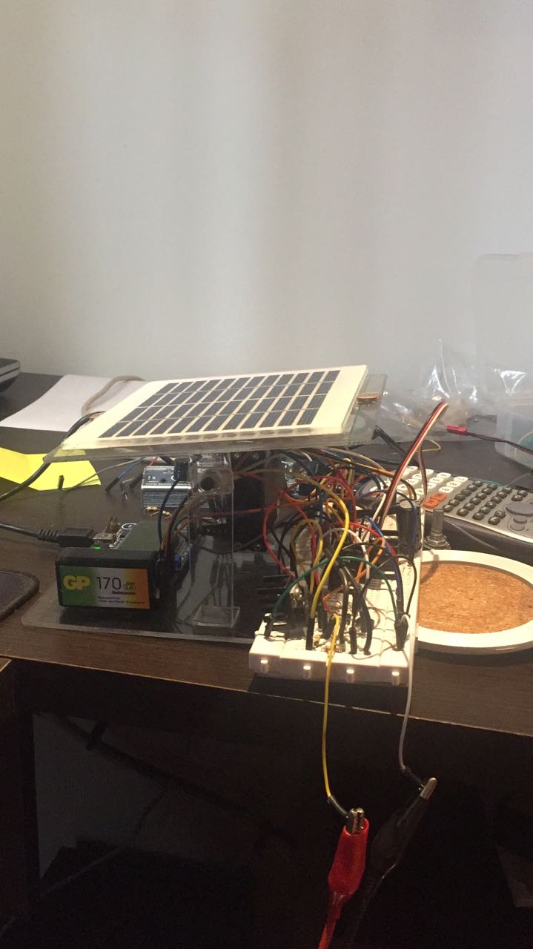

Picture 3. Test three.

4.Fourth test: We checked the sense that the system has with movement light. Getting the expected result which is that the panel follows the light taking advantage of the photoresistor’s read

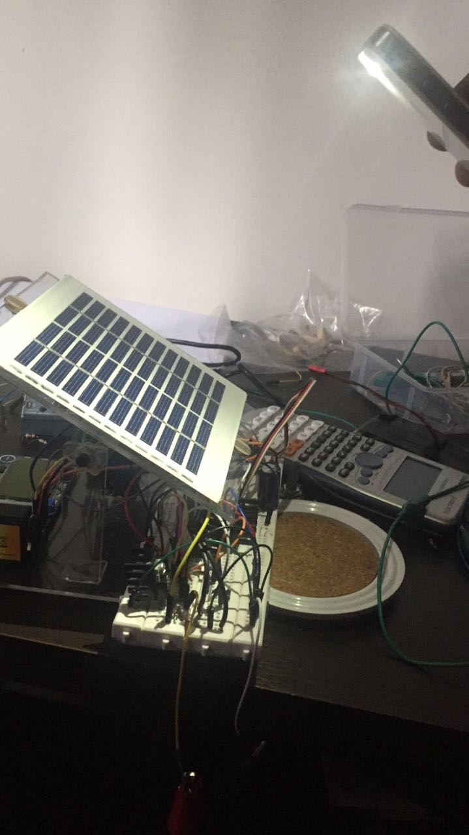

Picture 4. Following the light

# CONCLUSIONS

* The efficiency of a solar panel is directly from how much surface area is being affected by the sunlight.
* By using finite state machines an optimum efficiency can be archived in the implementation of a code to a microcontroller.
* By using sensors to read physical variables, these analog signals are translated into digital to obtain the desired data. To get this, photoresistor are used as a voltage divider so the microcontroller can read the analog data.
* A servomotor takes the position assigned to the percentage of PWM that is sent.
* Tools like the PWM allow the control of different actuators necessary to achieve the perfect operation of the system, such as the servos operation. This is done thanks to use od digital signal cycle which gives us the possibility of delivering analog values.

**Picture 6. Finite State Machine.**

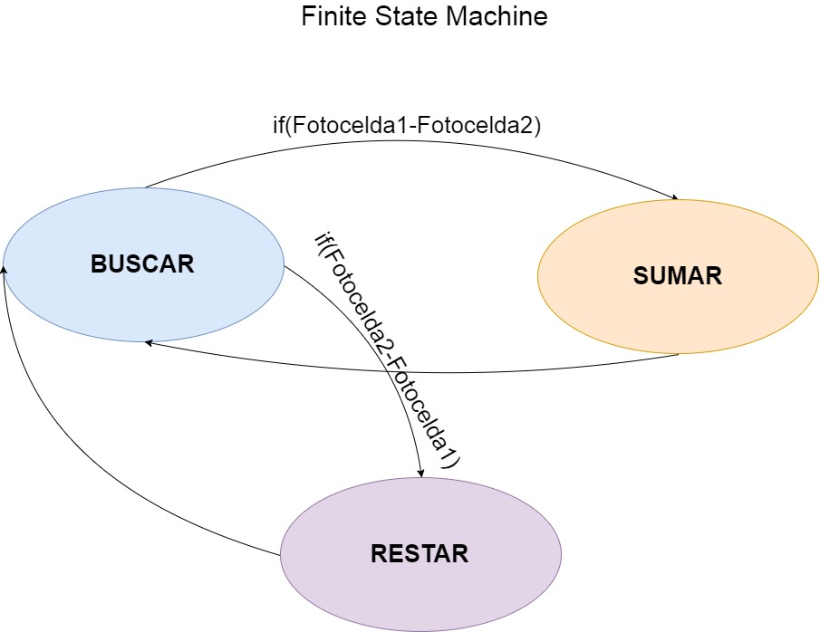

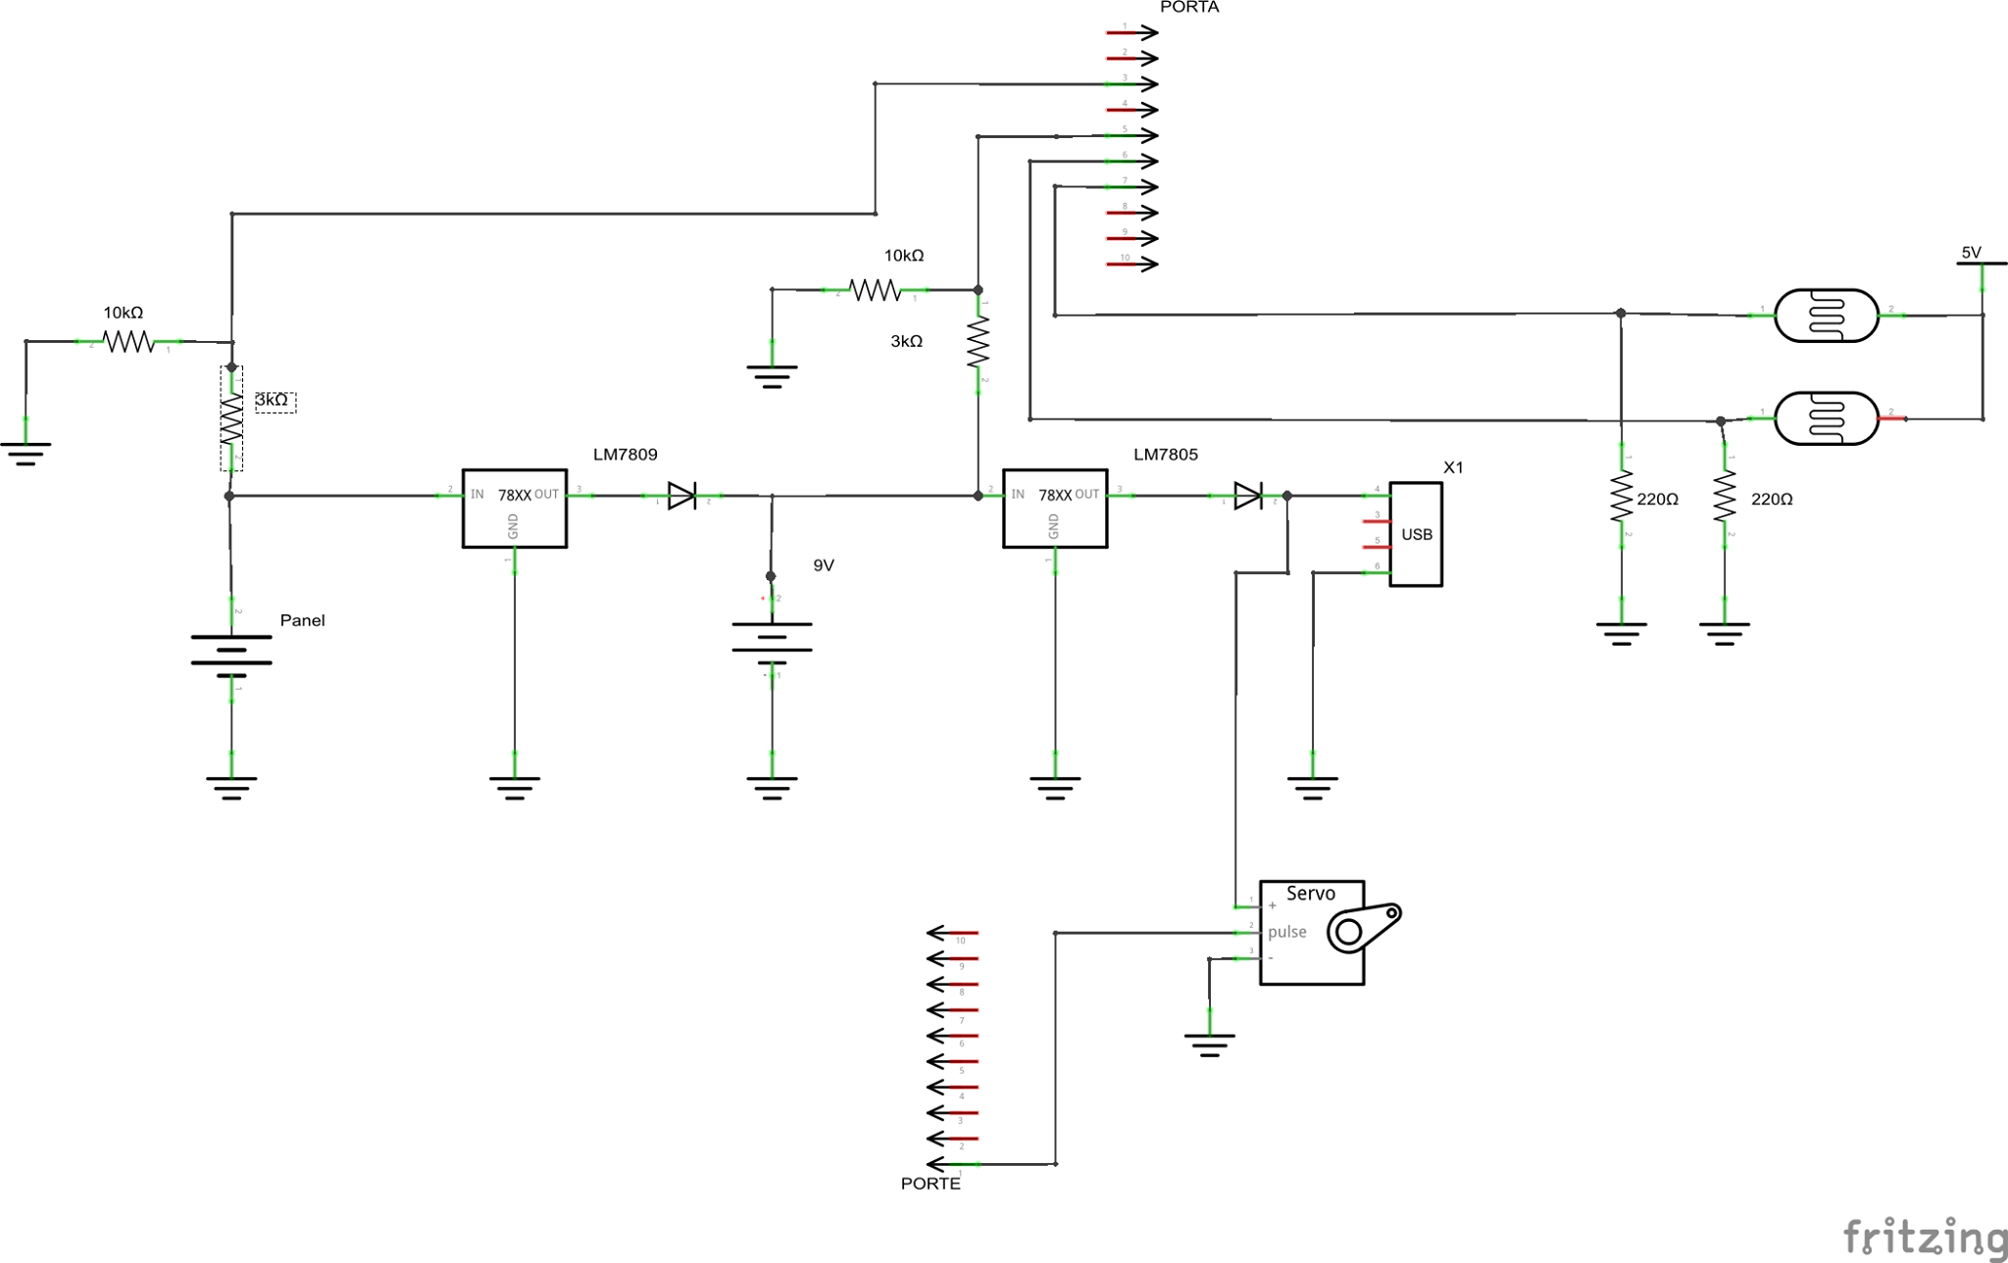

Picture 6. Schematics